Comparative Evaluation of Electrooculography(EOG) and MediaPipe-Based Blink Detection.

Abstract
This study presents a systematic comparison between two blink detection methods:
an electro-physiological approach using Electrooculography (EOG) and a computer vision technique based on the Eye Aspect Ratio (EAR) using MediaPipe’s Face Mesh model. Three adult male participants (ages 19–57) performed blink detection trials under varying ambient lighting (800 ± 20 lux and 300 ± 20 lux) and head orientations (neutral, left, right, up).
Blinks were identified by analyzing bandpass-filtered EOG signals (1–10 Hz) and EAR values. with thresholds set at 150 µV for peaks and 30 µV for valleys and EAR valleys dropping 0.10 in the MediaPipe approach. Synchronization was performed via the Lab Streaming Layer (LSL). Results indicate that EOG achieved consistently higher detection performance, with recall and precision scores above 0.95 across all conditions, and F1 scores close to 0.98. MediaPipe’s performance was more variable and sensitive to head movements and lighting, showing recall between 0.76 and 0.96, precision between 0.42 and 0.85, and lower F1 scores. These findings highlight EOG’s robustness for blink detection, while pointing to the need for improved visionbased algorithms under challenging conditions.

Introduction
Blink detection is a critical component in numerous domains such as human–computer interaction, medical diagnostics, and assistive technologies. Traditional EOG captures electrical signals generated by eye movements, providing high precision. Computer vision techniques, such as Google’s MediaPipe Face Mesh, enable real-time, non-invasive blink detection by analyzing facial landmarks and computing the EAR. However, these vision-based methods are sensitive to head pose changes and lighting variations. Despite their growing use, direct comparative evaluations between EOG and MediaPipe-based blink detection under controlled variations remain scarce. This study aims to fill this gap by evaluating the accuracy and robustness of both approaches in a controlled experimental setting.

Hypothesis
- H1: The EOG-based detection will outperform MediaPipe in terms of F1-score due to its direct measurement of electrical signals associated with eye movements, resulting in fewer false positives and negatives.
- H2: MediaPipe-based detection will show decreased accuracy during non-frontal head positions because of challenges in maintaining accurate facial landmark tracking.

Methodology

Participants
Three adult male participants aged 19, 21, and 57 were recruited. We acknowledge that the small, homogenous sample limits the generalizability of findings, but provides initial insight into method performance across a range of ages.

hardware/software requirements

SYSTEM COMPONENT SPECIFICATION / VERSION
EOG-BASED | Amplifier | BioSemi ActiveTwo EEG[1], ActiView v1.3.0[2]
 | Electrodes | Flat-type active electrodes[3]
 | Conductive Gel | Parker – Signa Gel[4]
 | Software | App-BioSemi[5]
 | Sampling Rate | 2048 Hz
MEDIAPIPEBASED | Camera | Microsoft LifeCam HD-3000 (1280×720 px, 30 fps)
 | Software | Custom Mediapipe Python script[5]
 | Frame Rate | 30 ± 5 fps
ADDITIONAL | Lux Sensor | Nothing Phone 2
 | Blink command System | Custom Dispatcher Python script[6]
 | Synchronization | Lab Streaming Layer (LSL) [7]
 | Test Computer | ROG-Strix G513IH
 | Analysis | Custom Jupiter analysis scrip[8]

System description
Below, Figure 1 shows a diagram of the complete pipeline of the experiment.
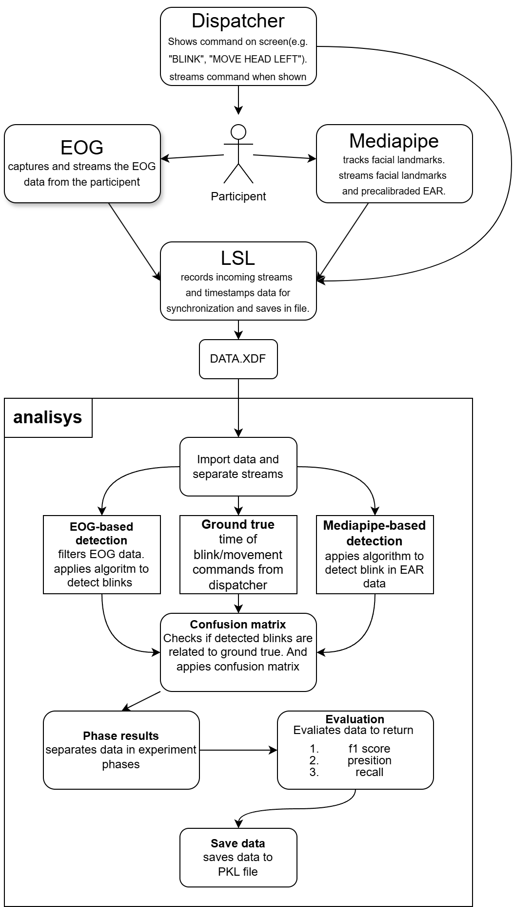
Figure 1. pipeline of the experiment.

EOG-based detection
The Electrooculography (EOG) system uses six electrodes placed around the eyes and ears to monitor eye movement and blinks (seen in figure 2). The electrode configuration is as follows:
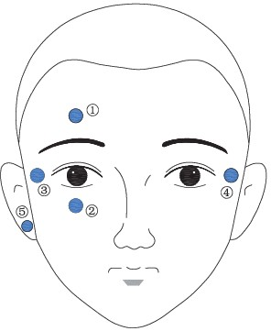
- Electrode 1 and Electrode 2: Placed above and below the eye, to capture vertical eye movements and blinks.
- Electrode 3 and Electrode 4: Positioned at the left and right temples, used for horizontal eye movement detection.
- Electrode (5) and Electrode (6): Located on the front and back of the right earlobe. Electrode 5 serves as the reference and electrode 6 serves as ground.

Figure 2. Shows placement of
EOG electrodes.
Blink detection focuses on signals from electrode 1 and electrode 2.
A bandpass Butterworth filter (1–10 Hz) is applied to remove baseline drift and noise. After filtering:
- A peak in electrode 1(above +150 µV) and
- A valley in electrode 2 (below –30 µV, i.e. inverted exceeds +30 µV) are used to identify a blink. If both features occur within 0.1 seconds of each other, a blink is registered. The average timestamp of the peak and valley is recorded as the blink moment. Figure 2 is a representation of a identified blink.

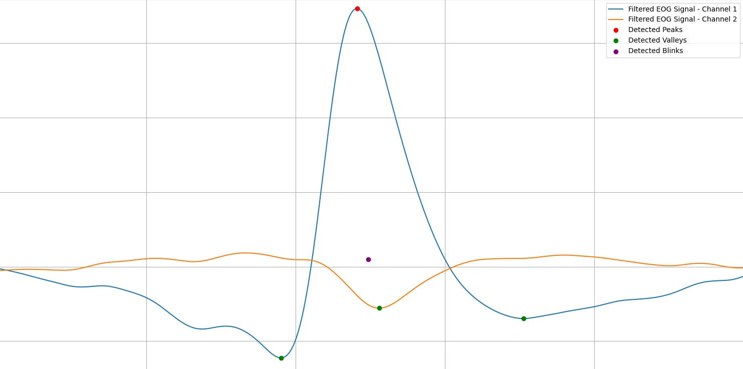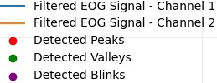
Figure 3. Blink detection from EOG.

MediaPipe-based detection

MediaPipe is an open-source framework by Google for real-time perception tasks, such as tracking hands, face, and body pose. It is fast, lightweight, and accurate, making it ideal for computer vision applications.
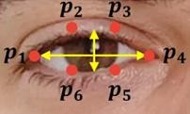
For blink detection, MediaPipe uses the Face Mesh model, which tracks 478 facial landmarks, including those around the eyes.
The blink detection algorithm is based on the Eye Aspect Ratio (EAR):
- EAR formula: EAR = (‖P2 − P6‖ + ‖P3 − P5‖) / (2 × ‖P1 − P4‖). • A lower EAR means the eye is more closed.
Figure 4. EAR landmarks
- When the EAR drops sharply (below a threshold of 0.10), a valley is detected.
Detection Algorithm Steps:
- MediaPipe tracks eye landmarks frame-by-frame.
- EAR is calculated for both eyes.
- A valley (EAR < 0.10) indicates a potential blink.
- If valleys in both eyes occur within 0.5 seconds, it's considered a blink.
- The average timestamp of both valleys is recorded as the blink moment.

Figure 5 is a visualization of a detected blink with the detection algorithm.
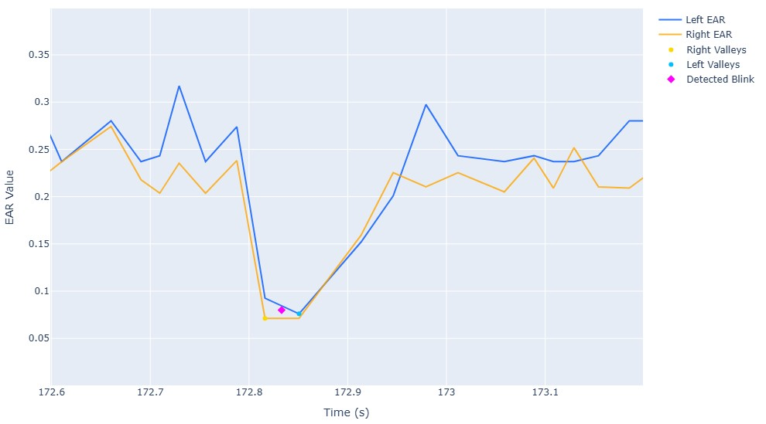
Figure 5. Shows detected blink from EAR.

Experiment Design

Environment
Experiments were conducted against a mat white background with two lighting conditions:
bright (800 ± 20 lux) and dim (300 ± 20 lux).

Instrumentation and Positioning
- Camera: Mounted 1.5 m from participant’s nose tip at eye level, centered.
- EOG Electrodes: Placed like described in “EOG-Based Detection”, Conductive gel is applied to the electrodes.

Data Recording & Synchronization
In this experiment five data streams are recorded:
- EOG: Send the EOG data with a EEG Channel Subset = 32. The reference channels are CMS, DRL. And recorded at 2048 Hz (default for BioSemi ActiveTwo).

- EAR: Sends the EAR of the left and right eye at HZ 30 ± 5.

- Mediapipe FPS: sends a string every loop in the mediapipe code to calculate the FPS of the other mediapipe streams across the experiment.

- Face landmarks: sends all 478 landmarks output by Mediapipes face mesh model at HZ 30 ± 5. This is done for possible future improvements on the Mediapipe blinking detection system.

- Dispatcher: The dispatcher sends the current command given to the participant. This is used to compare detected blinks to expected blinks at Hz 1.

All streams are synchronized via LSL.
LSL gives a raw XDF file that includes all synchronized streams. After analysis the data is stored in a Pickle(pkl) file.

Evaluation Metrics
To evaluate the performance of both blink detection methods, a modified confusion matrix is used. This matrix consists of three components:
- True Positives (TP): Correctly identified blinks (blinks detected on a 1 second time window when blink command was given).
- False Positives (FP): Incorrectly identified blinks (blinks detected outside the time window, or multiple blinks detected in the same time window).
- False Negatives (FN): Missed blinks that should have been detected.
From these values, common performance metrics can be calculated:
- Precision: TP / (TP + FP) — how many detected blinks were actually correct.
- Recall (Sensitivity): TP / (TP + FN) — how many actual blinks were successfully detected.
- F1 Score: 2 × (Precision × Recall) / (Precision + Recall) — the combination of precision and recall, providing a balanced performance measure.

Experimental Procedure

Preparation phase
- Confirm room lighting and record lux.
- Seat participant, adjust chair so eyes are level with camera.
- Apply EOG electrodes and check signal quality.
- Initialize LSL, launch MediaPipe and EOG software.

Experimental Procedure

Phase | Description | Blink Trials/ time | Conditions
Rest | Baseline recording with no instructions | N/A | 120 seconds | 800 lux
Blink | Blink every 3 s while facing camera | 120 | 360 seconds | 800 lux
Rest | Allows the participant to rest | N/A | 120 seconds | 800 lux
Movement | Blink every 3 s while looking left, right, and up | 39 per direction (117)  360 seconds | 800 lux
Lighting | No commands; light reduced to 300 lux | N/A | 120 seconds | 300 lux
Blink | Blink every 3 s facing camera | 120 | 360 seconds | 300 lux
Rest | Allows the participant to rest. | N/A | 120 seconds | 300 lux
Movement | Blink every 3 s while looking left, right, and up | 117 | 360 secondes | 300 lux

A total of 8 Phases, 474 blink trials with 4 different head orientations and 2 different lighting conditions were recorded. The duration of the experiment is 32 minutes without setup, teardown and signal checking. The estimated total duration of the experiment is 45 minutes.

Results & Analysis

Overall Performance
Across all conditions and participants, the EOG-based system consistently outperformed MediaPipe in blink detection. Figure 6 summarizes the average precision, recall, and F1-scores across different lighting and pose conditions:
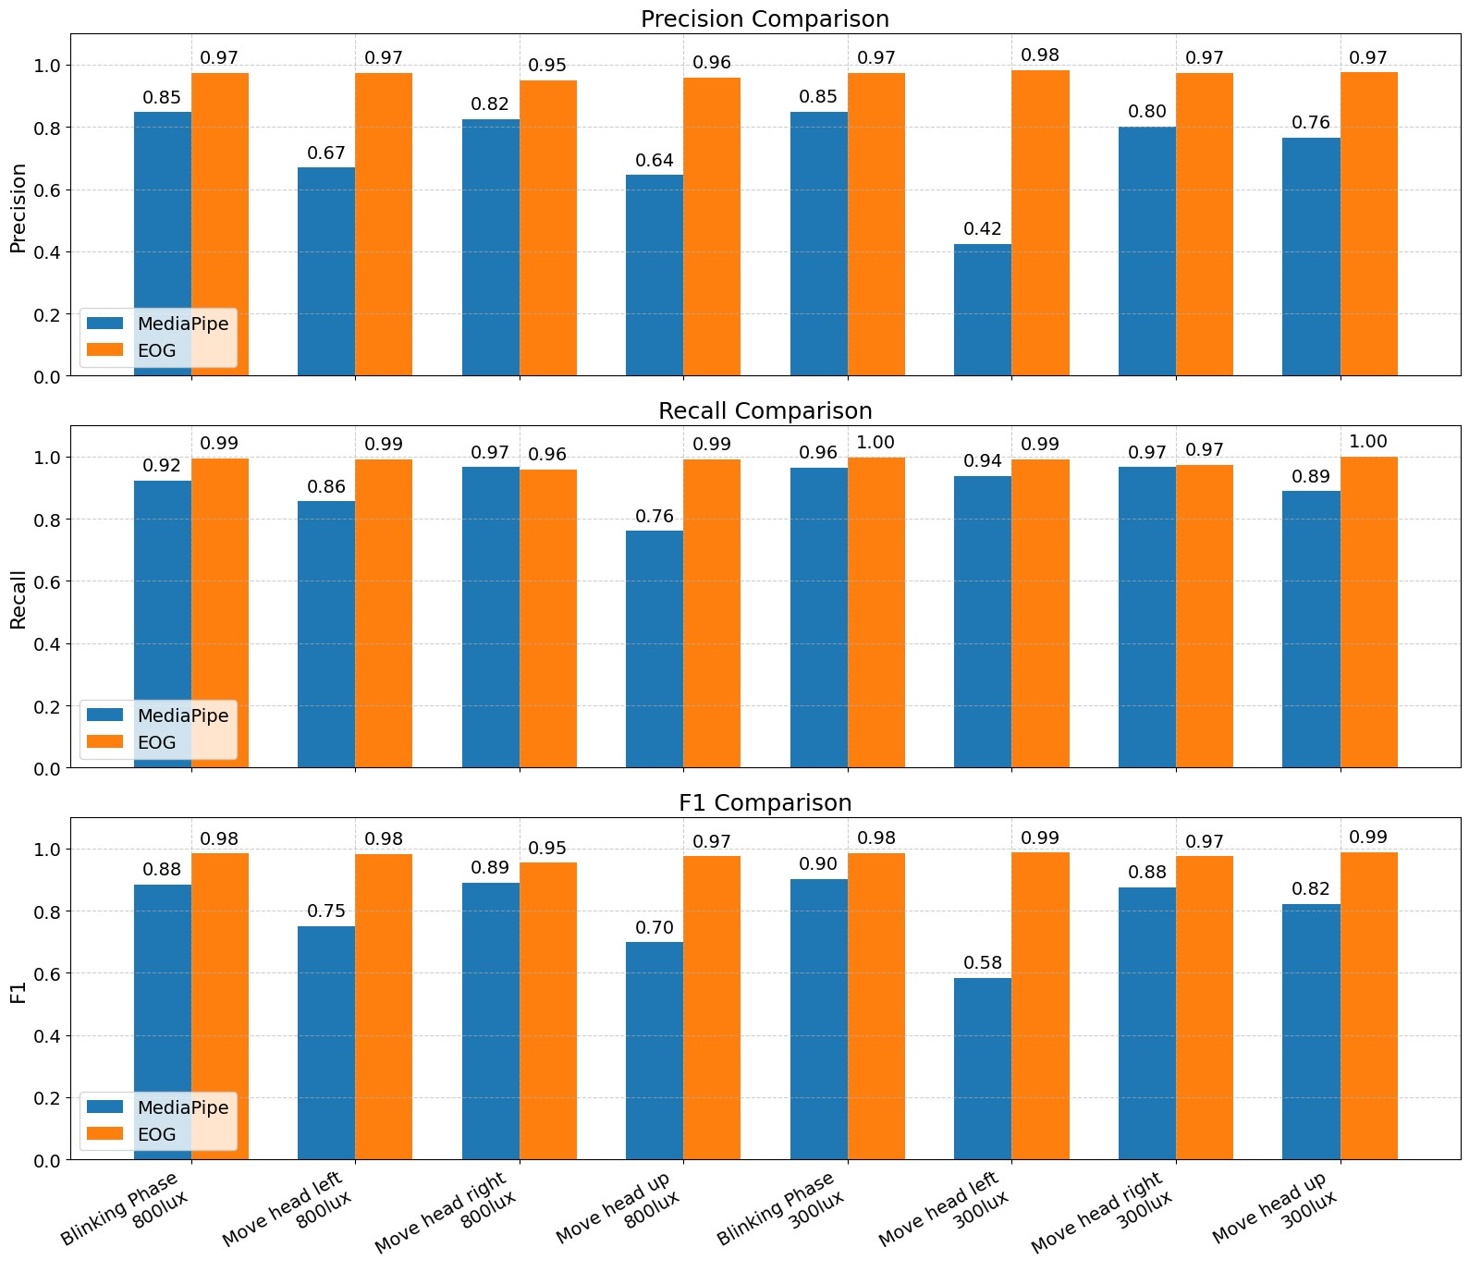
Figure 6. comparison of performance metrics

Results per participant
The results reveal notable differences in blink detection performance between participants, particularly with MediaPipe.
Participant 1 showed consistently high scores across all conditions with both MediaPipe and EOG, suggesting stable tracking and minimal detection issues.
Participant 2 also performed well, though MediaPipe showed a higher false positive rate during the blinking phase (34 FPs at 800 lux).
In contrast, Participant 3 had significantly lower MediaPipe performance, especially during head movements— for example, a precision of only 0.24 during left head movement at 300 lux and 0.28 during up head movement at 800 lux.

Participant 1
Participant 1 is a 19-year-old male with mild hyperopia (+0.5 diopters in both eyes). Table 1 details blink detection performance for different phases and lighting conditions:
Phase | Lux | System | TP | FP | FN | Recall | Precision | F1
Blinking Phase | 800 | Mediapipe | 120 | 1 | 0 | 1.00 | 0.992 | 0.996
 |  | EOG | 120 | 2 | 0 | 1.00 | 0.984 | 0.992
Move head left | 800 | Mediapipe | 39 | 4 | 0 | 1.00 | 0.907 | 0.951
 |  | EOG | 39 | 1 | 0 | 1.00 | 0.975 | 0.987
Move head right | 800 | Mediapipe | 39 | 9 | 0 | 1.00 | 0.813 | 0.897
 |  | EOG | 39 | 1 | 0 | 1.00 | 0.975 | 0.987
Move head up | 800 | Mediapipe | 34 | 2 | 5 | 0.872 | 0.944 | 0.907
 |  | EOG | 39 | 0 | 0 | 1.00 | 1.000 | 1.000
Blinking Phase | 300 | Mediapipe | 120 | 10 | 0 | 1.00 | 0.923 | 0.960
 |  | EOG | 120 | 0 | 0 | 1.00 | 1.000 | 1.000
Move head left | 300 | Mediapipe | 38 | 46 | 1 | 0.974 | 0.452 | 0.618
 |  | EOG | 39 | 0 | 0 | 1.00 | 1.000 | 1.000
Move head right | 300 | Mediapipe | 39 | 5 | 0 | 1.00 | 0.886 | 0.940
 |  | EOG | 39 | 0 | 0 | 1.00 | 1.000 | 1.000
Move head up | 300 | Mediapipe | 36 | 3 | 3 | 0.923 | 0.923 | 0.923
 |  | EOG | 39 | 0 | 0 | 1.00 | 1.000 | 1.000
Table 1

Participant 2
Participant 2 is a 21-year-old male with no vision impairments. Table 2 summarizes the results:

Phase | Lux | System | TP | FP | FN | Recall | Precision | F1
Blinking Phase | 800 | MediaPipe | 120 | 34 | 0 | 1.00 | 0.779 | 0.876
 |  | EOG | 120 | 2 | 0 | 1.00 | 0.984 | 0.992
Move head left | 800 | MediaPipe | 39 | 7 | 0 | 1.00 | 0.848 | 0.918
 |  | EOG | 39 | 1 | 0 | 1.00 | 0.975 | 0.987
Move head right | 800 | MediaPipe | 38 | 6 | 1 | 0.974 | 0.864 | 0.916
 |  | EOG | 37 | 2 | 2 | 0.949 | 0.949 | 0.949
Move head up | 800 | MediaPipe | 34 | 0 | 5 | 0.872 | 1.000 | 0.932
 |  | EOG | 39 | 3 | 0 | 1.000 | 0.929 | 0.963
Blinking Phase | 300 | MediaPipe | 114 | 3 | 6 | 0.950 | 0.974 | 0.962
 |  | EOG | 120 | 0 | 0 | 1.000 | 1.000 | 1.000
Move head left | 300 | MediaPipe | 39 | 2 | 0 | 1.000 | 0.951 | 0.975
 |  | EOG | 39 | 0 | 0 | 1.000 | 1.000 | 1.000
Move head right | 300 | MediaPipe | 37 | 6 | 2 | 0.949 | 0.860 | 0.902
 |  | EOG | 39 | 1 | 0 | 1.000 | 0.975 | 0.987
Move head up | 300 | MediaPipe | 35 | 2 | 4 | 0.897 | 0.946 | 0.921
 |  | EOG | 39 | 1 | 0 | 1.000 | 0.975 | 0.987
Table 2

Participant 3
Participant 3 is a 57-year-old male with hyperopia (+1,75 diopters in right eye and +1.25 diopters in left eye). Table 4 shows his performance metrics:
Phase | Lux | System | TP | FP | FN | Recall | Precision | F1-score
Blinking Phase | 800 | MediaPipe | 92 | 25 | 28 | 0.767 | 0.786 | 0.776
 |  | EOG | 118 | 6 | 2 | 0.983 | 0.952 | 0.967
Move head left | 800 | MediaPipe | 21 | 39 | 18 | 0.538 | 0.350 | 0.424
 |  | EOG | 37 | 1 | 2 | 0.949 | 0.974 | 0.961
Move head right | 800 | MediaPipe | 38 | 7 | 1 | 0.974 | 0.844 | 0.905
 |  | EOG | 37 | 4 | 2 | 0.949 | 0.902 | 0.925
Move head up | 800 | MediaPipe | 18 | 47 | 21 | 0.462 | 0.277 | 0.346
 |  | EOG | 38 | 1 | 1 | 0.974 | 0.974 | 0.974
Blinking Phase | 300 | MediaPipe | 113 | 49 | 7 | 0.942 | 0.698 | 0.801
 |  | EOG | 119 | 10 | 1 | 0.992 | 0.922 | 0.956
Move head left | 300 | MediaPipe | 32 | 104 | 7 | 0.821 | 0.235 | 0.366
 |  | EOG | 38 | 2 | 1 | 0.974 | 0.950 | 0.962
Move head right | 300 | MediaPipe | 37 | 9 | 2 | 0.949 | 0.804 | 0.871
 |  | EOG | 36 | 3 | 3 | 0.923 | 0.923 | 0.923
Move head up | 300 | MediaPipe | 34 | 30 | 5 | 0.872 | 0.531 | 0.660
 |  | EOG | 39 | 1 | 0 | 1.000 | 0.975 | 0.987
Table 3

Impact of Lighting
The experimental results clearly demonstrate that lighting conditions significantly affect detection accuracy, particularly for MediaPipe. Although recall generally remains high or even improves slightly under lower lighting, precision tends to decrease (seen in figure 7). Especially for certain types of movements, resulting in an increase in false positives. For instance, during the “move head down” task, MediaPipe’s precision dropped from a 0,92 at 800 lux to 0,75 at 300 lux, while recall slightly increased from 0,94 to 0,96. This trade-off causes variations in the overall F1 score depending on the specific movement. Nevertheless, the system maintains reasonable performance even at reduced lighting levels. These findings indicate that while MediaPipe is relatively robust across typical indoor lighting conditions, dimmer environments introduce more noise into the detection results. In contrast, the EOG-based method exhibits consistent score across all lighting levels, maintaining high precision and recall for every task. For example, EOG’s F1-score for the "Move head up" task remained at 0.98 under both 800 lux and 300 lux conditions. This consistency highlights that EOG detection is largely unaffected by lighting variations. Meanwhile, Mediapipe drops in precision under low-light conditions reflects its greater dependence on visual cues and image quality. Therefore, ensuring adequate lighting is crucial when utilizing camera-based systems like Mediapipe for blink detection.
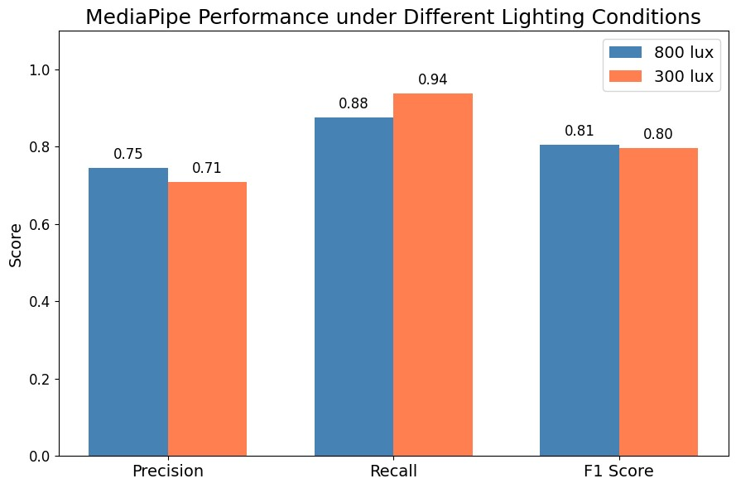
Figure 7 Graf shows precision recall and f1 score over all data with separate lighting

Impact of Head Movement
The data clearly shows that head movement significantly affects the performance of the MediaPipe-based blink detection system, regardless of lighting conditions. Specifically, when participants moved their heads — particularly to the left or upward — MediaPipe showed a marked increase in false positives and a drop in precision and F1-score. For example, during "Move head left" tasks, MediaPipe’s precision dropped as low as 0.51, indicating frequent misclassifications. In contrast, EOG-based detection remained consistently accurate across all head movement directions, maintaining high precision, recall, and F1-scores. This suggests that head movement introduces noise or misinterpretation in the visual landmark tracking used by MediaPipe, while EOG, being based on electrical signals, is much more resilient to such motion artifacts. Overall, head movement presents a clear challenge for vision-based blink detection systems, while EOG remains robust and reliable.

Discussion
The results of this comparative evaluation highlight the influence of head orientation and lighting on the performance of two blink detection methods: Electrooculography (EOG) and MediaPipebased computer vision. Both methods demonstrated distinct strengths and limitations under varying experimental conditions.
EOG consistently achieved higher precision, recall, and F1-scores across all lighting and head orientation scenarios. Its sensitivity to subtle voltage changes associated with eye muscle activity makes it a highly reliable method. In contrast, MediaPipe’s performance was more variable. Notably, under certain head orientations, its blink detection accuracy declined significantly. This suggests that MediaPipe's reliance on visible facial landmarks renders it more susceptible to occlusion and changes in facial orientation.
The robustness of EOG under different lighting conditions further emphasizes its suitability for real-world applications, where consistent illumination cannot always be guaranteed. However, EOG’s reliance on physical electrodes and susceptibility to signal drift introduces complexity in setup and calibration. MediaPipe, while less accurate, offers a fully contactless and rapiddeployment alternative that may be sufficient for applications where ultra-high precision is not critical.
Interestingly, inter-subject variability — including differences in facial structure, blinking style, and expressiveness — had a greater impact on MediaPipe than on EOG. This suggests that generalizing computer vision–based models without subject-specific calibration poses a challenge for robust detection performance.
A key limitation of this study is the small sample size (three participants), which may not capture the full range of variability across populations and

Conclusion and Future Work
This study shows that EOG outperforms MediaPipe in blink detection accuracy, particularly under challenging conditions involving varying lighting and head orientations. While EOG is more reliable, MediaPipe offers a contactless alternative suitable for less demanding contexts. Each method presents trade-offs between precision, usability, and setup complexity. Future research should explore hybrid approaches and MediaPipe’s performance could potentially be improved with further optimizations, such as facial landmark smoothing, dynamic thresholding based on head orientation, and the use of a higher-resolution, higher-frame-rate camera. The current study used a static camera, future work could explore camera placement strategies that maintain a consistent frontal view of the face to enhance MediaPipe’s performance.

References
- BioSemi, “ActiveTwo system.” [Online]. Available: https://www.biosemi.com. [Accessed: Mar. 19, 2025].

- BioSemi, “Flat-type active electrodes.” [Online]. Available: https://www.biosemi.com/flat_electrode.htm. [Accessed: Mar. 19, 2025].

- BioSemi, “ActiView v1.3.0.” [Online]. Available: https://www.biosemi.com/download.htm. [Accessed: Mar. 19, 2025].

- Parker Labs, “SignaGel active-electrode.” [Online]. Available: https://www.parkerlabs.com/products/signagel-electrode-gel/. [Accessed: Mar. 19, 2025].

- D. Rutten, “Custom MediaPipe Python script.” GitHub, 2025. [Online]. Available:
https://github.com/Dorus-rutten/Comparative-Evaluation-of-Electrooculography-EOGand-MediaPipe-Based-Blink-Detection..git [Accessed: Mar. 19, 2025].

- D. Rutten, “Custom Dispatcher Python script.” GitHub, 2025. [Online]. Available:
https://github.com/Dorus-rutten/Comparative-Evaluation-of-Electrooculography-EOGand-MediaPipe-Based-Blink-Detection..git [Accessed: Mar. 19, 2025].

- SCCN, “Lab Streaming Layer (LSL).” GitHub, 2025. [Online]. Available: https://github.com/sccn/labstreaminglayer. [Accessed: Mar. 19, 2025].

- D. Rutten, “Custom Jupyter analysis script.” GitHub, 2025. [Online]. Available: https://github.com/Dorus-rutten/Comparative-Evaluation-of-Electrooculography-EOGand-MediaPipe-Based-Blink-Detection..git [Accessed: May 19, 2025].

